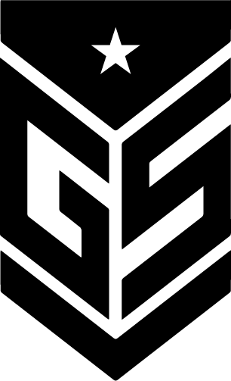
Racing Centre
PORTUGAL

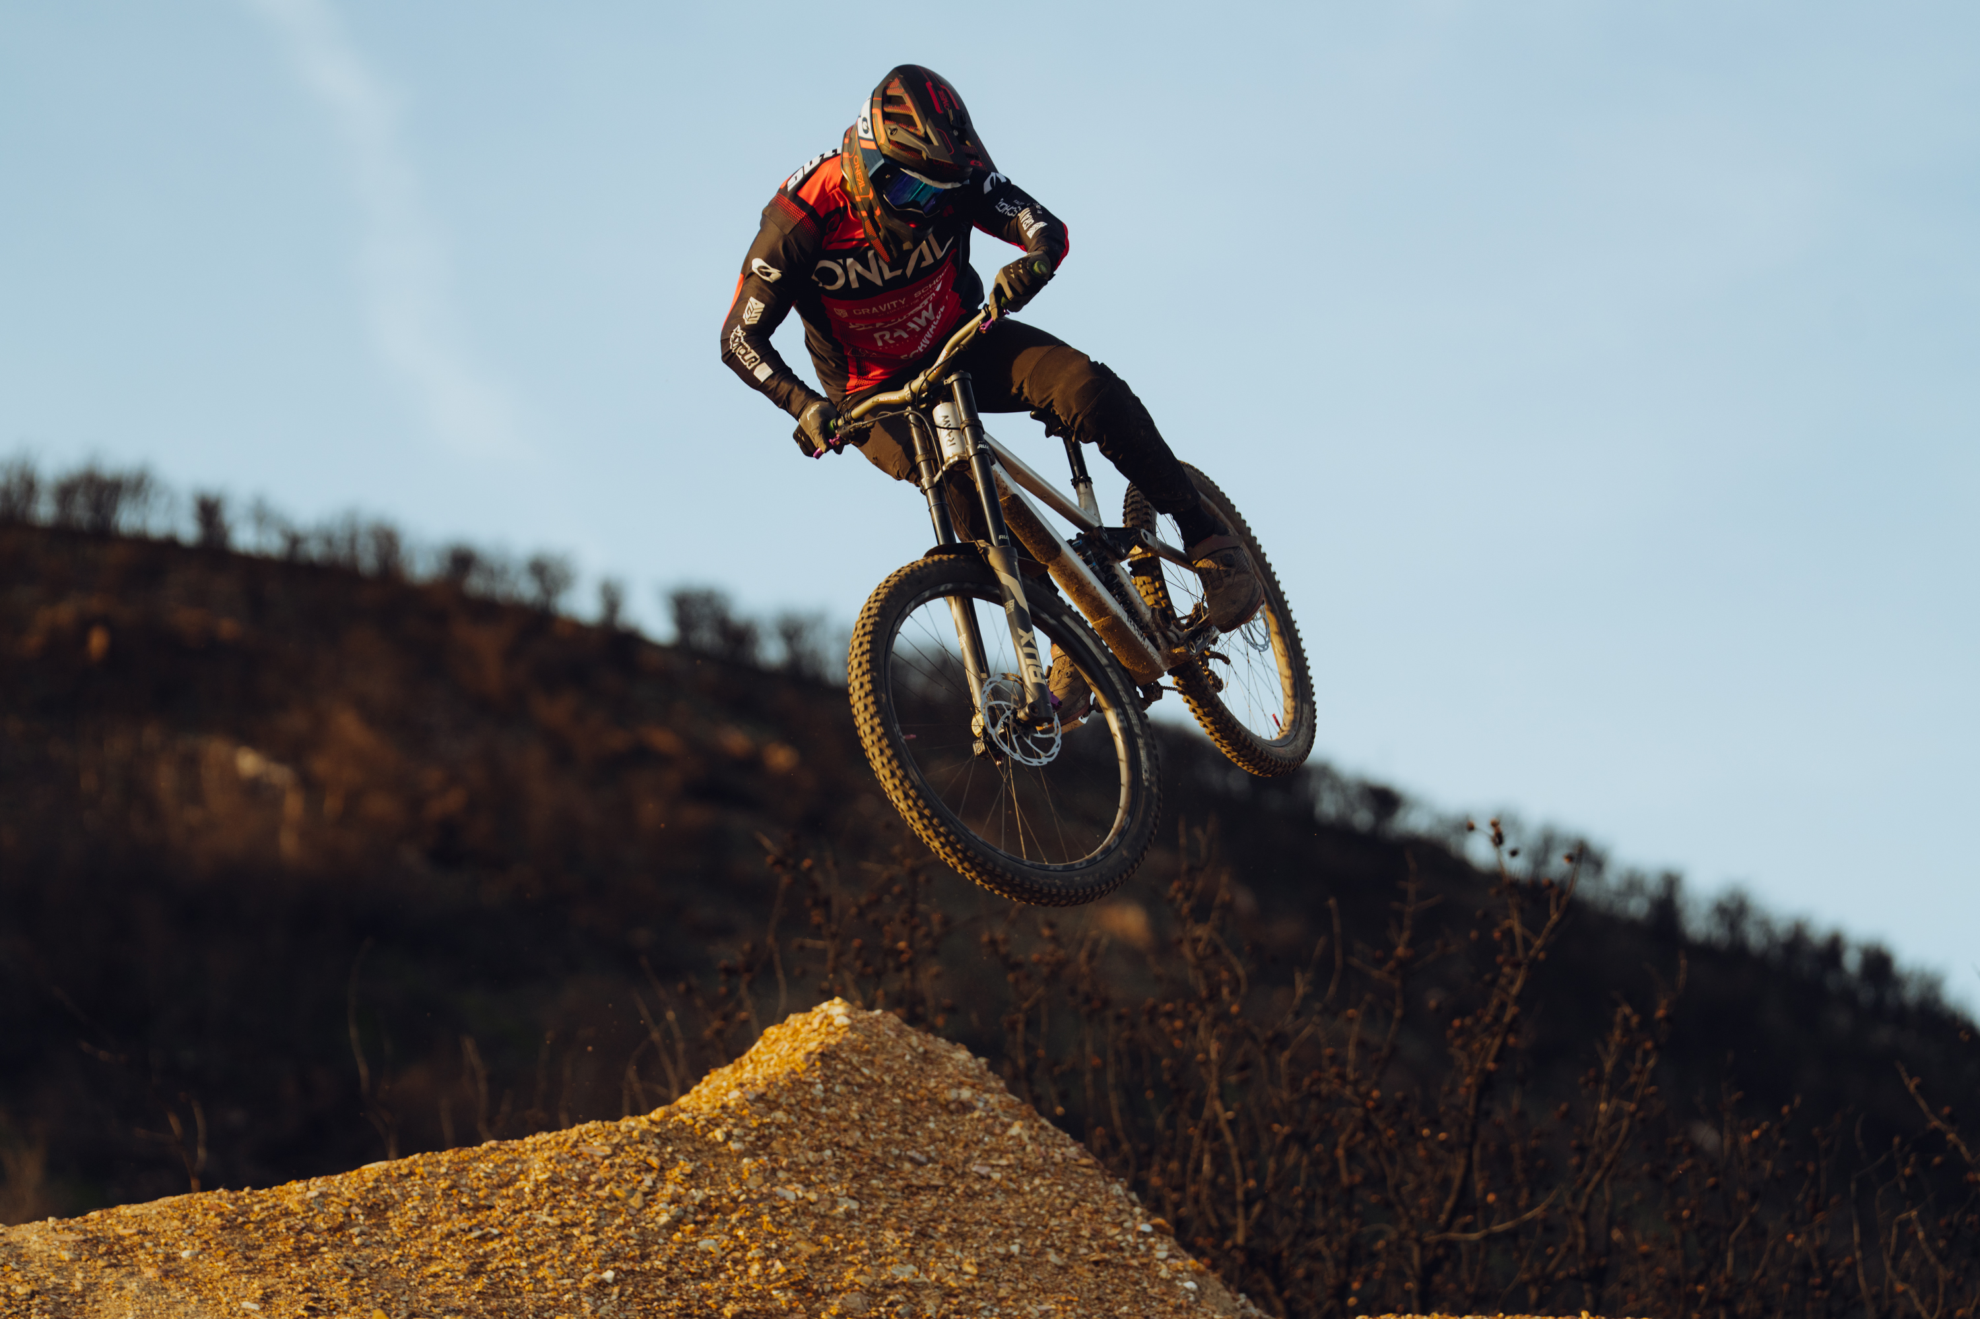


Downhill MTB
Race Coaching Camps

Start the 2026 race season
ahead of the rest!

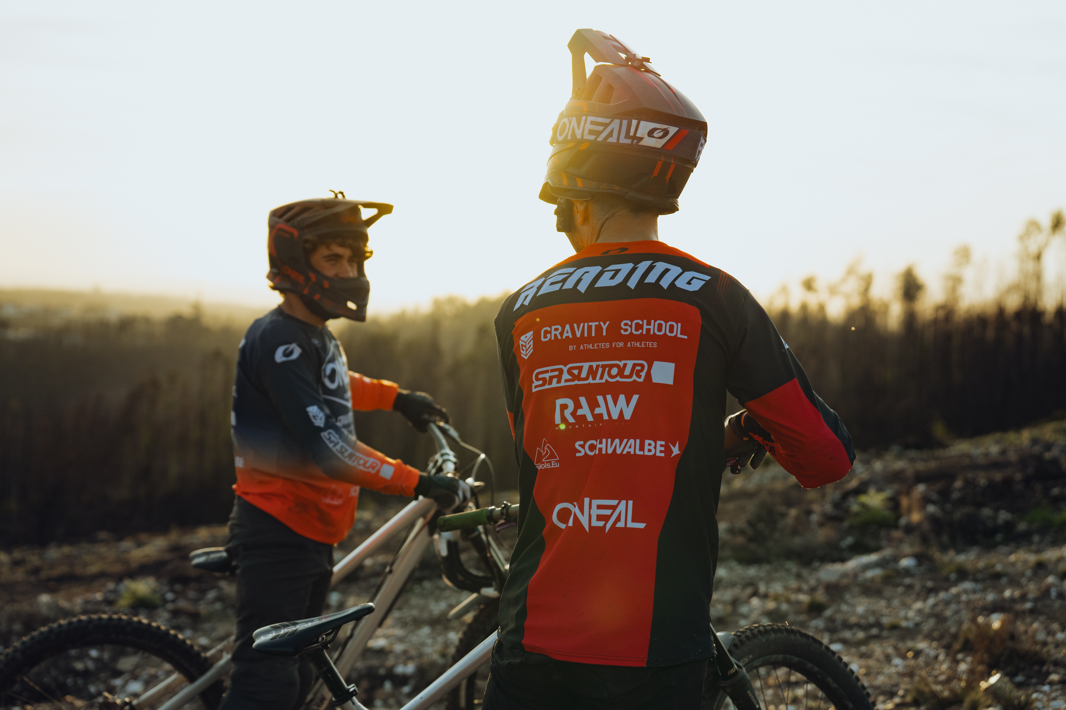
Professional coaching
by Jack Reading

Freelap Live
Timing System

Specially prepared
world level race tracks
by Trail Tools builders
INCLUDING:
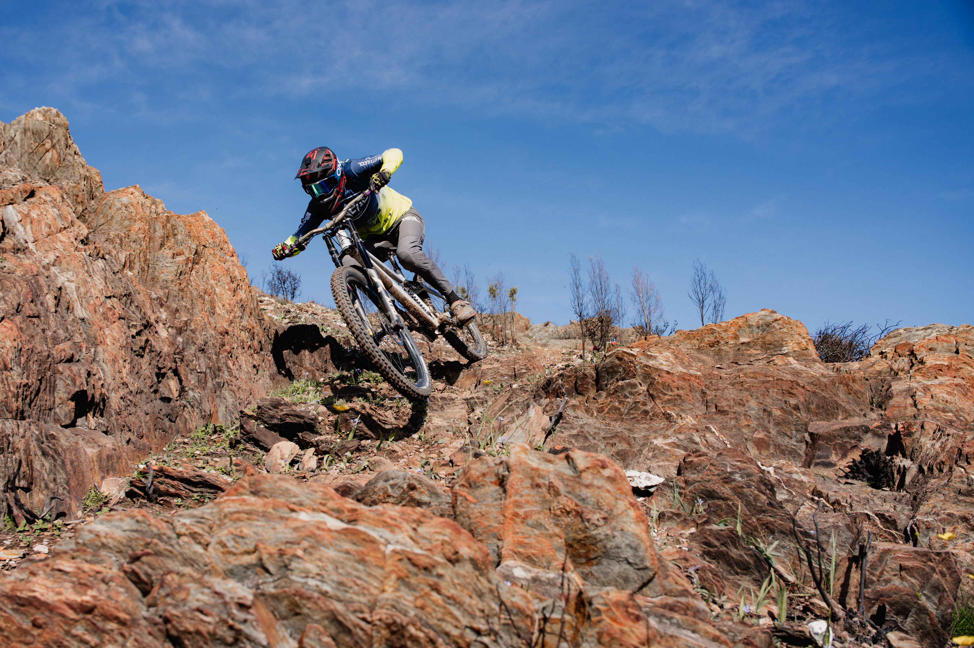
Uplift at 3 venues
Video Analysis
Mechanic pit support
Stay at Gravity School Villa
Excellent Food
Airport Transfers
Physio Treatment
Physical Training Advice
Fitness Evaluation
The Racing Centre Camp
Half Term

Costs £2250 all-inclusive 8 days
(Excluding flights)
(Additional parent joining fee £750)

February 15th – 22nd

The ultimate coaching experience
to start the 2026 race season

Schedule*:

Sunday Travel Day, check in, bike build, track walk

Monday Ride Day 1: Fenix Bike Park, timed session

Tuesday Ride Day 2: Fenix Bike Park, race run session

Wednesday Lousa Ride Day 3: Louzan Park + Go Karting*

Thursday Rest/Reset day at the Racing Centre

Friday Tarouca Ride Day 4: Tarouca DH, timed session

Saturday Ride Day 5: Fenix Bike Park fun laps

Sunday Travel Day

*See page 3 for additional information

The Racing Centre Camp

Additional Information

Once collected at Porto Airport by our transfer service the only things not included in the price are personal purchases. Everything else is included in the prepaid fee.

The riders will stay at the new Gravity School Villa where we will have breakfast and lunch each day. Some evening meals will be here, others will be at restaurants. Rooms are either twin or triple rooms, with shared bathrooms. Gravity School staff are on site permanently. The Racing Centre is located on the shuttle road for Fenix bike park, and less than 10 minutes from the city of Agueda.

On arrival riders will build their own bikes, and be responsible for the general maintenance of their bikes throughout the week. Mechanical assistance will always be available from Jack, Rueben and Sam, and a focus point of the week will be on helping riders to improve their own skills in terms of bike mechanics. Riders will be shown how to perform a fork service, bleed brakes, and efficiently change tyres, as well as other skills.

The schedule is subject to changes based on weather and any uncontrollable factors. Ride days 1 and 2 include the track walk of “Through the V”. The focus during these days is on race craft and preparation and execution of fast timed runs. Riders learn the track, discuss lines and build speed with constant coaching from Jack. Ride day 2 will include a proper “race run session” in the afternoon. Riders will get the chance to do 2 race runs, with their best time counting for their result. Ride day 4 at Tarouca will also include a track walk and timed session. Coaching includes video analysis with trackside filming and GoPro follow cam footage for riders to evaluate.

Go Karting is dependent on the weather and will incur an extra charge of €50 cash per person, for anyone who wants to take part.

Physio treatment can be booked depending on availability and comes at an additional cost. Physical training options can be discussed with Jack at any point during the camp.

Bikes will be packed by the rider on Saturday evening, with assistance from Gravity School staff where necessary.

Riders should have travel insurance that covers downhill mountain biking in place before they pay their deposit to book a place on a camp.

ANY QUESTIONS PLEASE EMAIL: jack@gravityschoolmtb.com
OR CALL: 07868152371 TO TALK WITH JACK

